Load-balancer

***Configure Classic Load balancer***.

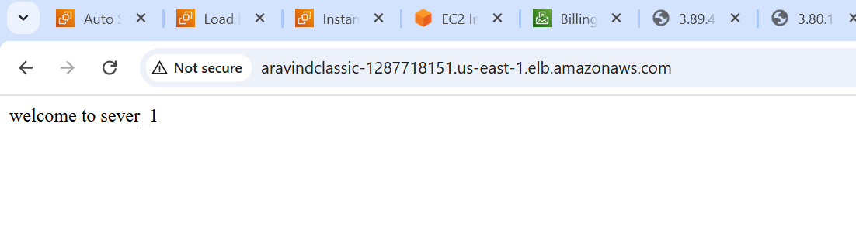

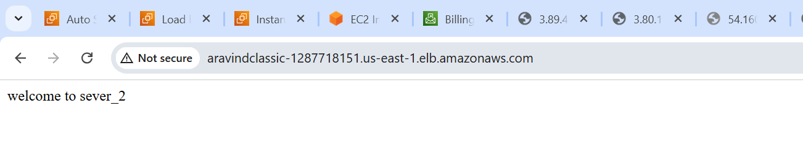

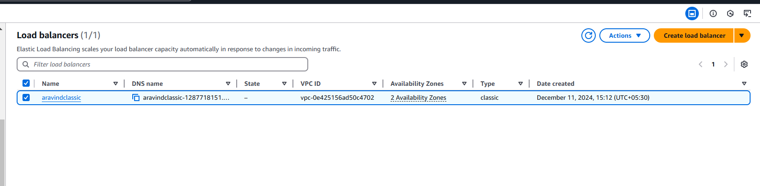

***Configure Application Load balancer.***

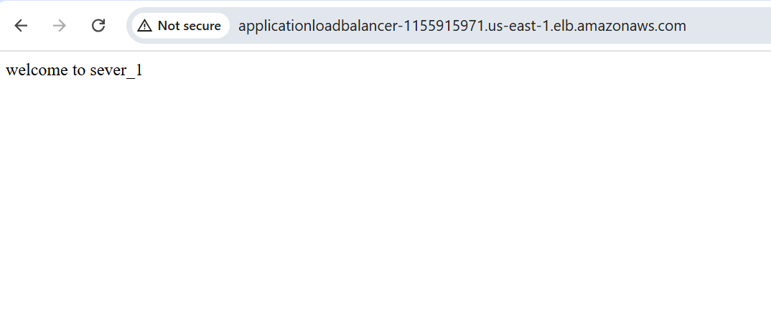

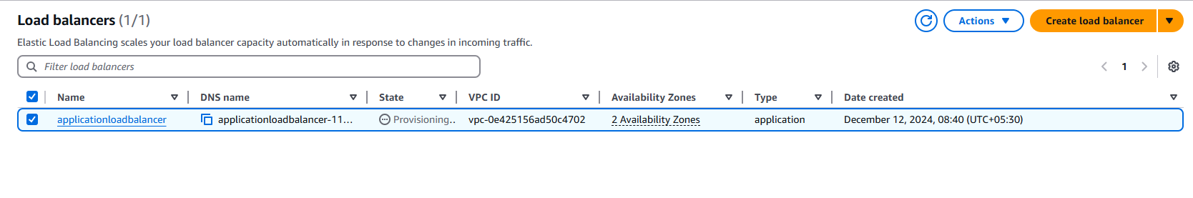

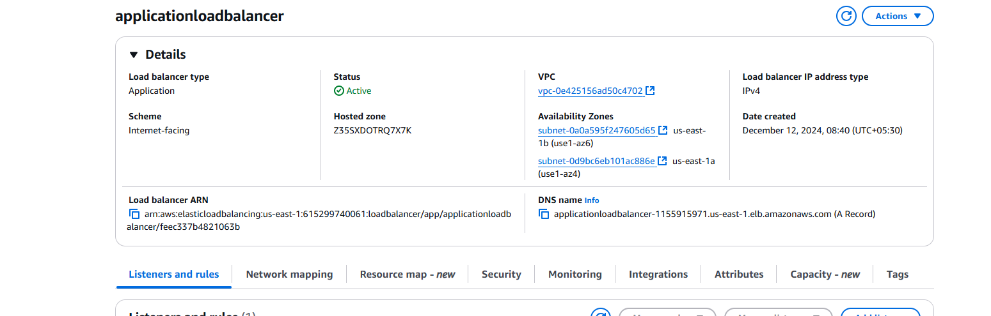

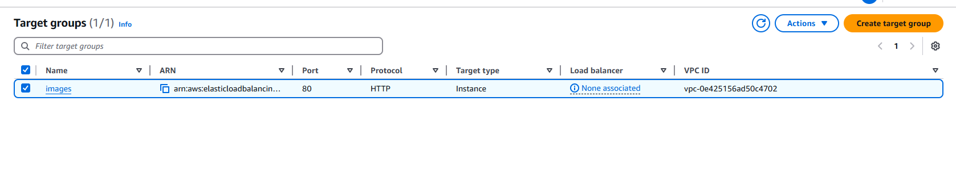



***Configure Network Load balancer.***

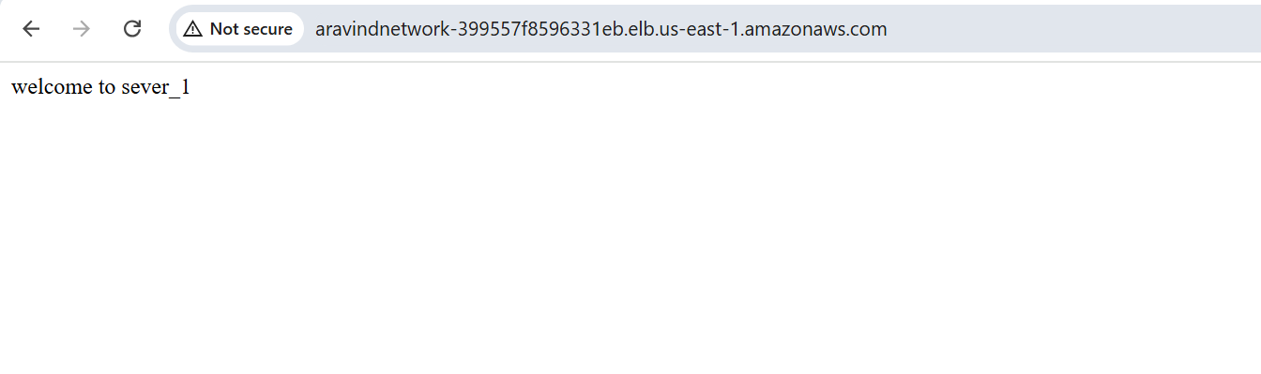

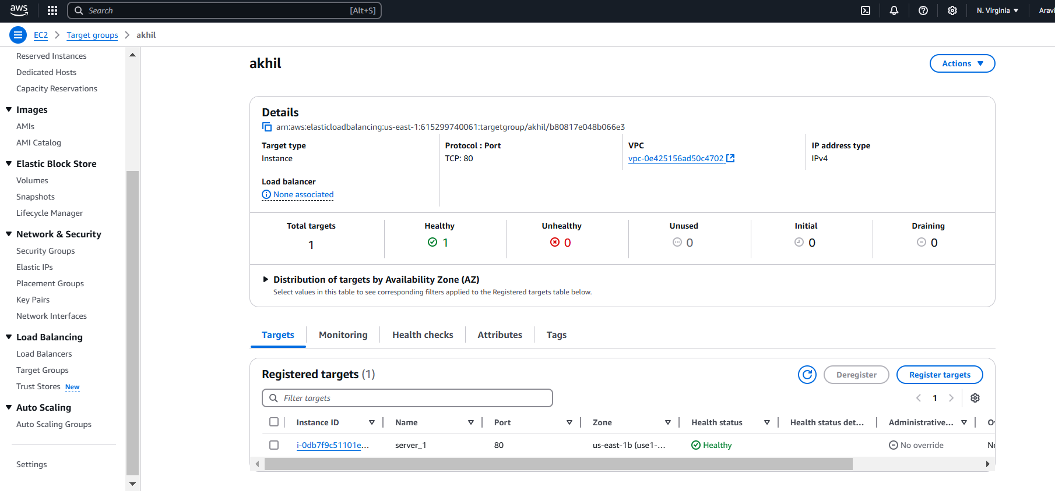

***Attach SSL for application load balancer.***

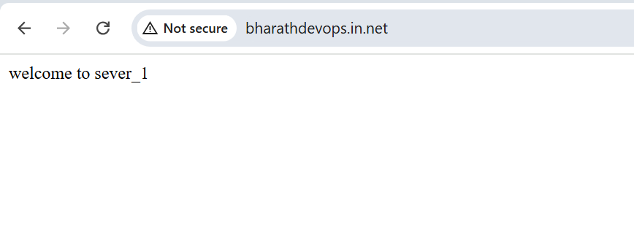

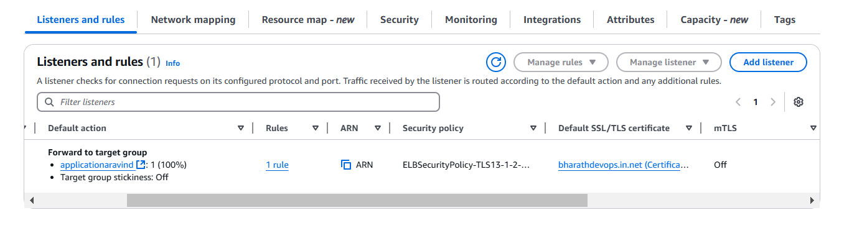

***Map Applciation load balancer to R53.***

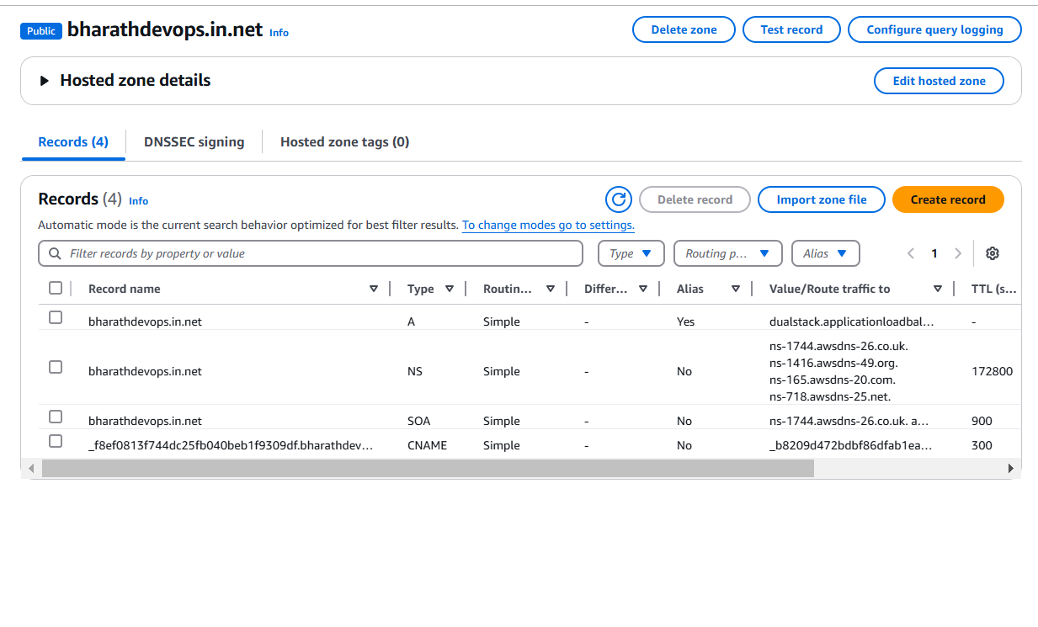

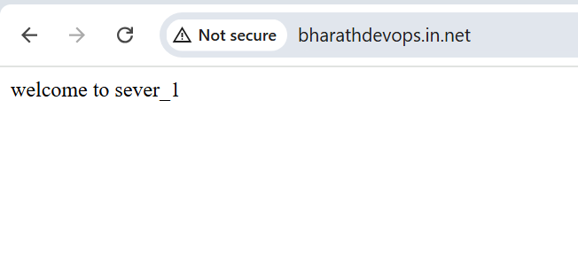

***Push the application load balancer logs to s3.***

